REPORT OF INDEPENDENT REGISTERED PUBLIC ACCOUNTING FIRM

To the Shareholders and Board of Directors of
Perritt Funds, Inc.

Opinion on the Financial Statements

We have audited the accompanying statement of assets and liabilities, including the schedule of investments, of Perritt Funds, Inc., comprising Perritt MicroCap Opportunities Fund (the “Fund”), as of October 31, 2025, the related statement of operations for the year then ended, the statements of changes in net assets for each of the two years in the period then ended, the financial highlights for each of the five years in the period then ended, and the related notes (collectively referred to as the “financial statements”). In our opinion, the financial statements present fairly, in all material respects, the financial position of the Fund as of October 31, 2025, the results of its operations for the year then ended, the changes in net assets for each of the two years in the period then ended, and the financial highlights for each of the five years in the period then ended, in conformity with accounting principles generally accepted in the United States of America.

Basis for Opinion

These financial statements are the responsibility of the Fund’s management. Our responsibility is to express an opinion on the Fund’s financial statements based on our audits. We are a public accounting firm registered with the Public Company Accounting Oversight Board (United States) (“PCAOB”) and are required to be independent with respect to the Fund in accordance with the U.S. federal securities laws and the applicable rules and regulations of the Securities and Exchange Commission and the PCAOB.

We conducted our audits in accordance with the standards of the PCAOB. Those standards require that we plan and perform the audit to obtain reasonable assurance about whether the financial statements are free of material misstatement whether due to error or fraud.

Our audits included performing procedures to assess the risks of material misstatement of the financial statements, whether due to error or fraud, and performing procedures that respond to those risks. Such procedures included examining, on a test basis, evidence regarding the amounts and disclosures in the financial statements. Our procedures included confirmation of securities owned as of October 31, 2025, by correspondence with the custodian. Our audits also included evaluating the accounting principles used and significant estimates made by management, as well as evaluating the overall presentation of the financial statements. We believe that our audits provide a reasonable basis for our opinion.

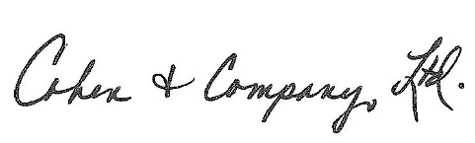
We have served as the Fund’s auditor since 2009.

COHEN & COMPANY, LTD.
Cleveland, Ohio
December 26, 2025

